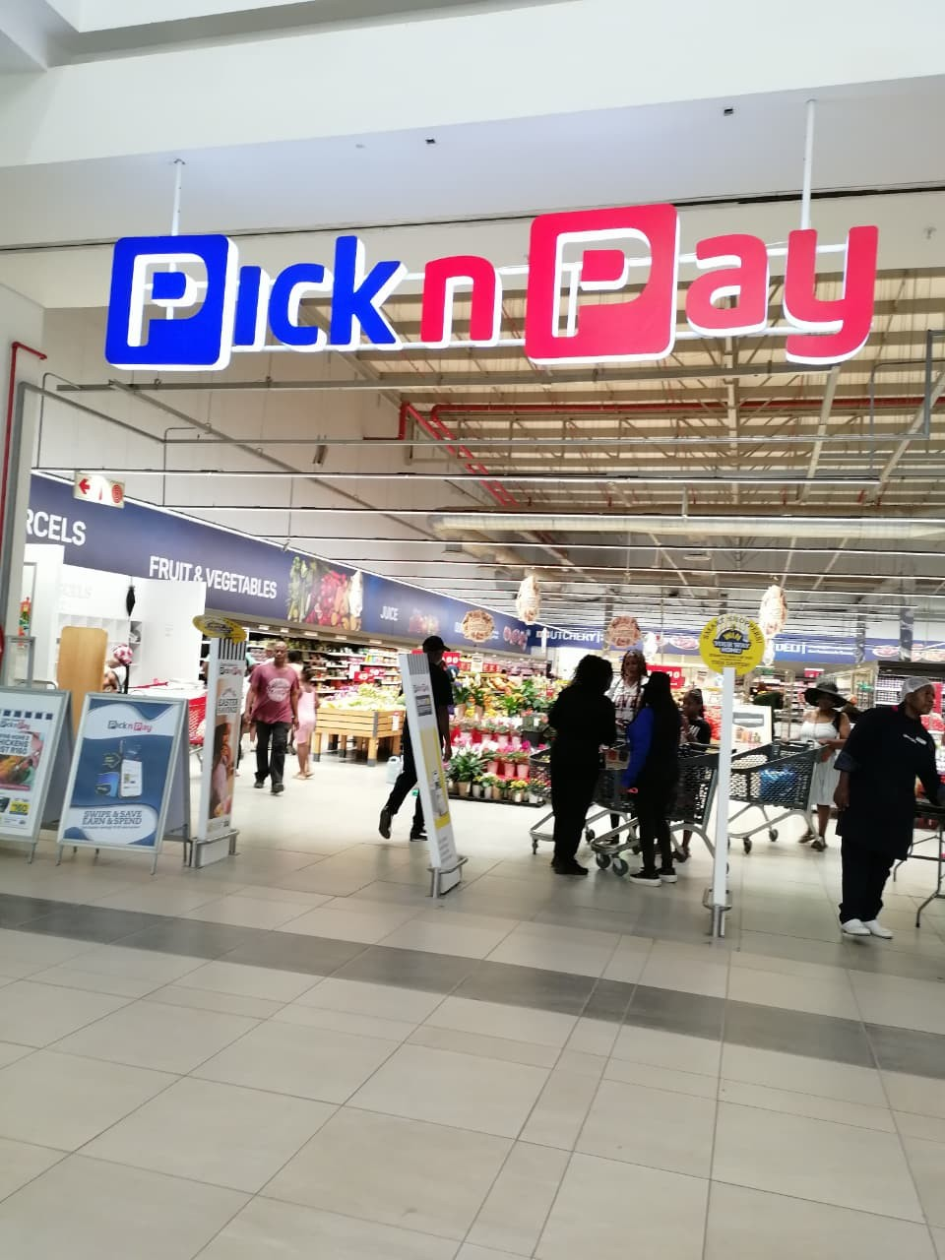  Pick n pay proposal | Abstract  Pick n Pay is one of most grocery stores in south Africa that sells good food products.  Prosperity Chauke  Web Development

Table of Contents
Introduction 2
Mission and vision statements 3
Target audience 3
The specific goal 3
The PKI 3
The strength and weaknesses 4
Improvements that should be made 4
Propose website 5
Design and user experience 5
References 7

Introduction

- Pick and pay is a store that is located throughout the country of South Africa.
- It offers fresh fruits and vegetables, meat, poultry, seafood, dairy products, beverages, household cleaning products, personal care items, electrical appliances and wide range of general merchandise which therefore includes baby ware, health and beauty products, flowers.
- Pick and Pay was founded by Raymond Ackerman in South Africa in 1916.

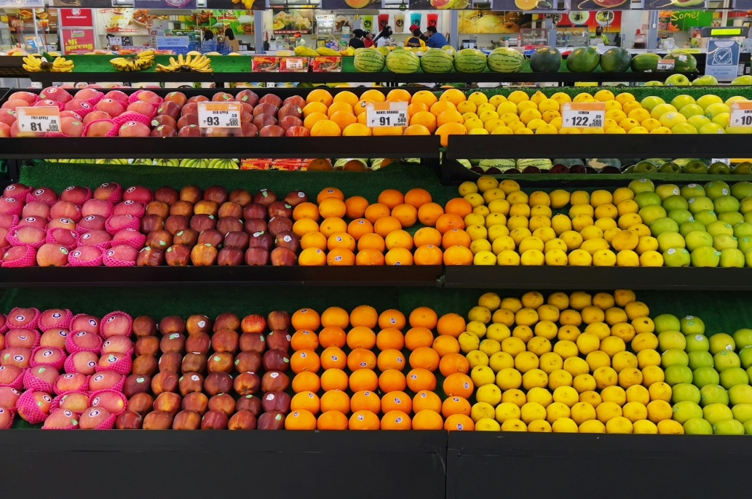
Figure 1:Fruits in the aisle
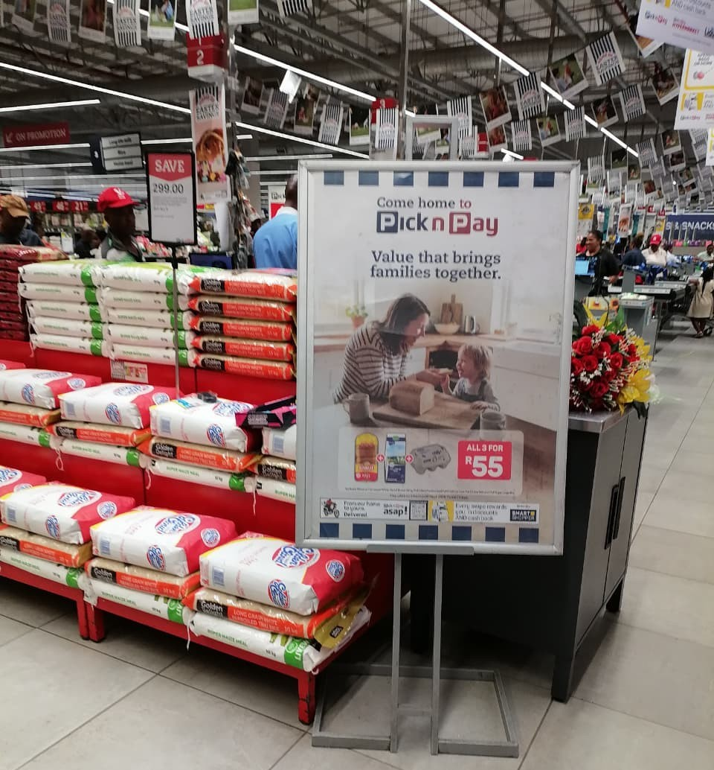

Mission and vision statements
- The Pick n pay mission is to serve, with their hearts they make the stores to be a great place that people want to be.
Values are:
- They nurture leadership and vision and as well as the reward innovation
- They support and participate in the communities and they foster personal growth and opportunity.

Target audience
- The store’s audience is a middle- and higher-income individuals and families.

The specific goal
- The store is focusing on the operational excellence in their supermarkets. The store is aiming to recapitalize by raising about R4 billion to strengthen financial stability.

The PKI
- The Pick n pay group has a very higher turnover as compared to the corresponding period, the group’s turnover has increased all up to 5.6% and they had an increase of about 1.9%. Their gross has also massively improved from 0.3% to 18.4%.

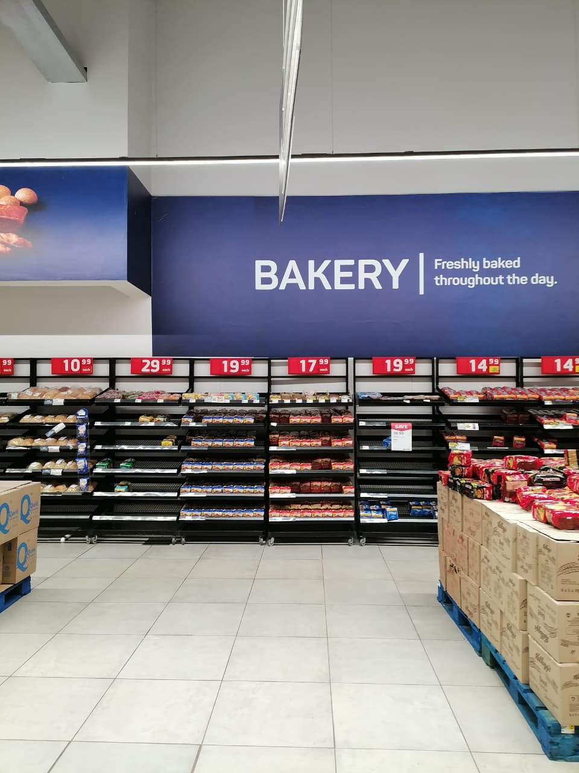
Figure 2 Bakery aisle in pick n pay store

The strength and weaknesses
The strength:
- They have a rapid online growth that boosts their sales through a new channel.
- Their customer loyalty is high due to the strong focus on their good service
The weaknesses:
- They have an oversized units that overwhelms their manufacturer.
- The company neglect their customer needs which result in them losing a substantial segment of the market.

Improvements that should be made
- The company should try to adjust their strategies in order to remain competitive while making profit.
- They can also strength the customer loyalty through enhanced service programs.

Propose website
- The Pick n Pay website offers a host of features that offer customers an enhanced shopping experience, these features include the multi-card loading, multiple orders per transaction and many more.
- Their website is very easy to navigate and helps the customer to find products quickly and efficiently.

Design and user experience
- Colour scheme: The website’s design brings -to -mind the sense of trust, reliability and customer satisfaction
- Typograph: The site’s design is clean and minimal, to facilitate a better user experience.
- The store’s app has been recently updated their app for better performance with the help of AI as their new user experience. The low fidelity of the pick n pay’s website is a simplified version that focuses on the functionality rather the visual design.
- The elements make the website more appealing & makes easier to use.
- Wireframe : homepage(will include the logo, navigation menu, hero section with hero shot picture) About us( navigation menu, details about pick n pay, footer), products( products offered, navigation menu, product banner) contact us page( navigation menu, call-to-action button, contact details of the store).

- I will be using html to structure my website, CSS for making my webpages to be more visual and JavaScript to add interactivity. Domain name=Pick n Pay.com
- Week1: Decided on which organisations to work on. Did my research on that.
- Week2: Started my proposals, gathered all on links on word. Edited them where possible. Went to the store of my organisation to take pictures.
- Week3: Edited the information once again. Started with the website.
- Week4: Submitted the part 1 then started with CSS and javascript.

- The budget was about R2.8billion non-cash store asset impairment in the Pick n Pay business

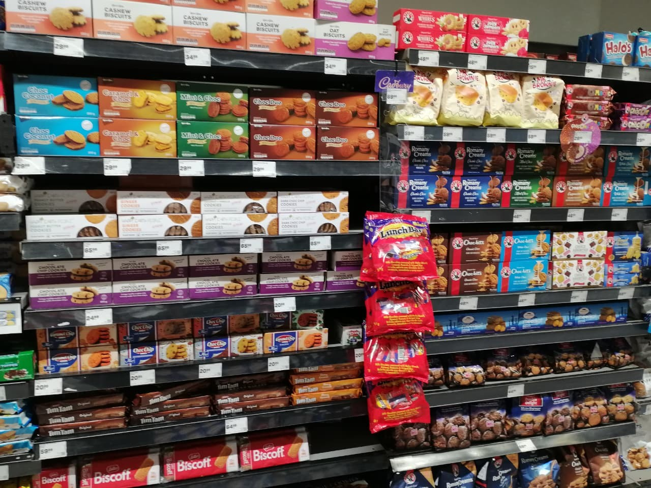
Figure 4: snacks aisle at pnp

References
Bizcommunity.com. Pick n Pay reveals strategy to restore its business,27 May 2025.[online]. Available at: https://www.bizcommunity.com/article/pick-n-pay-reveals-strategy-to-restore-its-business-128216a [Accessed 1 April 2026].
Bizcommunity.com. Pick n Pay’s digital evolution: Building a connected retail future,30 October 2025.[online]. Available at: https://www.bizcommunity.com/article/pick-n-pays-digital-evolution-building-a-connected-retail-future-171326a [Access 16 March 2026].
Geeksforgeeks. The relationship between visual design and user experience design,14 May 2024.[online]. Available at: https://www.geeksforgeeks.org/web-templates/the-relationship-between-visual-design-and-user-experience-design/ [Accessed 16 March 2026].
MBA Skool (2024). Pick n Pay SWOT Analysis, Matrix, & Revenue. [online] MBA Skool. Available at: https://www.mbaskool.com/swot-analysis/lifestyle-and-retail/9205-pick-n-pay.html [Accessed 1April 2026].
Pick n Pay Stores Ltd (2025). Pick N Pay Stores Limited-Audited annual financial results for the 53 weeks ended 02 March 2025. [online] Sharenet SENS. Available at: https://www.sharenet.co.za/v3/sens_display.php?tdate=20250526070500&seq=1 [Accessed 15 March 2026].
Pick N Pay store (2025). Pick N Pay. [online]. Available at: https://www.pnp.co.za/ [Accessed 17 March 2026]
UTC (2025). Pick n Pay. [online]. Available at: https://en.wikipedia.org/wiki/Pick_n_Pay [Accessed 18 March 2026].

